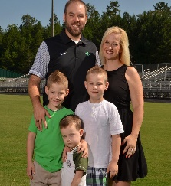
The Rasco Family

Dear Parents,
I am so pleased to welcome you and your child to First Baptist Church of Jasper Preschool & Kindergarten. What a great first week of school we had! We have an exciting year ahead of us with many new activities and adventures in store. With the beginning of the new school year in full swing, I wanted to take a moment to tell you about our monthly newsletter. Each newsletter will contain the unit of study that the students are working on, details about in-house guests or visitors that will be coming to the school, information about any preschool/Kindergarten needs, volunteering opportunities, and important dates or events that are coming up. So please take the time to read the newsletter each month, and do not hesitate to call or email me with any questions you may have. We are all looking forward to a wonderful 2017-2018 school year!

Cassie Rasco
Head of School
706-253-5017
preschool@fbcjasper.com

August Important Dates
Open House August 3
First Day of School August 7
NO SCHOOL – Solar Eclipse August 21
Picture Day/Curriculum Night August 22

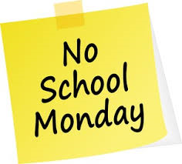

REMINDER: There will be no school on Monday August 21st due to the solar eclipse. School has been cancelled on this day for all Pickens County schools.

Fall pictures will be taken on August 22nd. We are trying something new this year – vintage pictures! Feel free to dress your child up in the theme of the background, which is pictured below. To make the pictures fun, we will have props for your child. Christmas and spring pictures will still be taken, and the spring pictures will be featured in our yearbook. We look forward to seeing all those smiling faces!

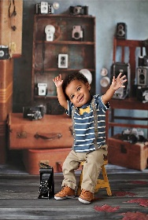

Tuesday, August 22nd we will hold our Curriculum Night for parents only. This is a drop-in event will begin with a mandatory meeting at 5:30 in Walker Hall.
This meeting must be attended by at least one parent, as crucial information concerning your child’s education will be reviewed. After the meeting, you can meet with your child’s teacher in their classroom to discuss any questions or concerns that may have arisen during the first few weeks of school.

New Entrance Security
We have changed the way the school entrance operates. From now on, the outer doors to the lobby will remain unlocked. Once you enter the building, please wait at the inner doors, which will remain locked at all times. Our doorbell will ring and we will come to let you in. We have also added security cameras at both entrances to the building. Ms. Marie, the administrative assistant, is now stationed in the front lobby as an extra resource for students and parents. All of these measures were put into place to ensure the safety of our school and our students.

We have begun accepting tuition payments online through PayPal. Once you have created a PayPal account, go to our website and scroll down to the PayPal payment buttons. Choose your payment options, log in to your PayPal account, and make your payment! You may still make your payments in cash or check, if you choose.
Scholastic book orders are due on the first of every month. The catalogs going home this month are for the month of September. Therefore, orders and payments are due on October 1st. A percentage of each order goes towards our school. If you have an order, please turn it in to your child’s teacher. Thank you!
Our first unit of study this year is My Family and Me (God Made Me Unique). We will be exploring the ins and outs of each individual child and their families. Our bible verse for this month is Psalms139:14 “I praise you, for I am fearfully and wonderfully made”, and we will focus on Adam and Eve and the importance of Creation. We will also be teaching the children that the world is bigger than they know by studying the Sun, Moon, Stars, and Outer Space as a whole. Our songs for this month are “He’s Got the Whole World In His Hands” and “Jesus Loves the Little Children”.

