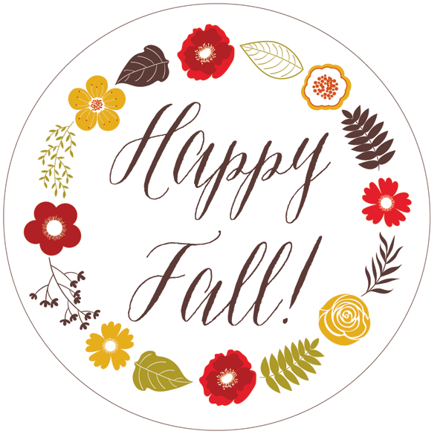

Dear Parents,
Our first month of the 2017-2018 school year is in the books! And what a wonderful and happy first month of school it was! I am so proud of how well our students handled the transition from summer fun, sleeping late, and playing all day to getting up early, focusing, paying attention, and learning. We have a lot of fun things coming up this fall, starting with our Donuts With Dad breakfast! We are looking forward to a memorable school year full of learning and fun!

Many blessings,

Cassie Rasco
Head of School
706-253-5017
preschool@fbcjasper.com

We would like to send out a special thank you to all of those who donated supplies, snacks, funds, and their time and energy to our school! Your contributions helped to make the start of this new school year the best one yet! We greatly appreciate all your support!
September Important Dates
NO SCHOOL – Labor Day September 4
Donuts With Dad September 13
NO SCHOOL – Fall Break September 18-22

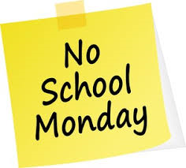
REMINDER: There will be no school on Monday September 4th in observance of Labor Day. School will resume on Tuesday September 5th.

Our Donuts With Dad event will be on Wednesday September 13th. We invite all our wonderful dads to come by and enjoy a hot breakfast with your child. This is a drop-in event that will run from 8:00 – 10:00 a.m. We will have pastries, biscuits, coffee, tea, and donuts, of course! We hope to see you there!

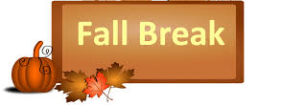
There will be no school September 18th – 22nd. All Pickens County schools will be closed for Fall Break. Enjoy the cooler weather and have fun! School will resume on Monday September 25th.
Do you have an interesting job? A fun story to tell? A unique pet to show, experiment to perform, or just have some extra time on your hands? We are looking for people to come to the school and get involved with our students. If you would like to come and host a career day, do an activity with the students, have a show and tell session, or volunteer in another way, please contact the office. These kinds of activities are enriching for the children, so please come and volunteer - we would love to have you here!

Tote Bag Fundraiser
We will be having a very fashionable fundraiser this month! We have an array of pretty tote bags in different sizes. These will be filled with themed goodies and put up for auction, with all the proceeds being used for improvements to the school. If you have any items you would like to donate to fill the tote bags, please contact the office. This is a great way to advertise your business!

New Entrance Security
We have changed the way the school entrance operates. From now on, the outer doors to the lobby will remain unlocked. Once you enter the building, please wait at the inner doors, which will remain locked at all times. Our doorbell will ring and we will come to let you in. These measures were put into place to strengthen the safety of our school and our students.
Tuition
Just a reminder, tuition is due on the first of every month. You may pay in cash, by check, or online from our website. This year we began taking online payments through PayPal. If you have any questions, please feel free to contact me and I can assist you.
You can now pay your child’s tuition and fees online through PayPal! You can choose a one-time or recurring payment. To make a recurring payment, you must first create your personal PayPal account. Once you have created your account, go to our website and scroll down to the PayPal payment buttons, choose your payment options, and make your payment
Scholastic book orders are due on the first of every month. A percentage of each order goes towards our school. If you have an order, please turn it in to your child’s teacher. Thank you!
Our unit of study this month is Community Helpers & Transportation (God Keeps Me Safe). Our bible verse for this month is Psalms 46 “God is my refuge and strength, a very present help in trouble”. This month we will focus on the story of the Good Samaritan and how helping others is a way in which we serve God. Our song for this month is “Oh, Be Careful Little Eyes What You See”.

