Dear Parents,
2018 is off to a great start at FBCJ Preschool & Kindergarten! After some missed days due to Mother Nature, we got back into the groove. We have our book fair happening all the way through February 9th, so make sure to swing by and pick up some great books and goodies! We hosted our Grandparent’s Day breakfast in January and had a terrific turnout. The yummy food and fun visits to the classrooms made for a wonderful morning with some of our students’ favorite people. We have fun things planned for this month, including Valentine’s Day parties and Dr. Seuss Day. Happy February!

Blessings,
Cassie Rasco

Valentine’s Day parties will be on… Valentine’s Day! Parties will be at 11:00 on February 14th in the classrooms. You are welcome to take your child home after the party, if you choose.
February Important Dates
Valentine’s Day Parties February 14
NO SCHOOL-Winter Break February 19-20
Make-Up Days February 21-23
Dr. Seuss Day February 28
There will be no school February 19th - 20th for Winter Break. School will resume on February 21st.

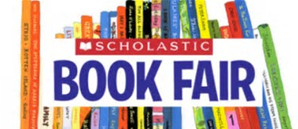
Our book fair will be open all the way through February 9th. You are welcome to come any time during the week to look around and shop. There is a wide array of items, including books, gifts, supplies, and more! A portion of the sales will go directly to go the school. Come by and have a look before it’s gone!
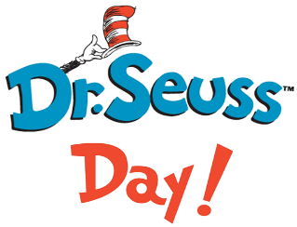

We will be celebrating Dr. Seuss Day on Wednesday, February 28th. We will be having fun activities all week long, including dress-up days, crafts, and of course a traditional snack of “green eggs and ham”! More information concerning the week’s activities will be coming soon.
High Tea Fundraiser

FBCJ Preschool & Kindergarten will be hosting High Tea on Saturday, March 17th from 10:00am - Noon. Join us for a morning full of treats, tea, and fun! There will be a kid’s fashion show, a silent auction, prizes, and more! Host a table for $120 or buy individual tickets for $15 each. Be sure to wear your favorite tea time hat or bonnet and support the important cause of Christian education in early childhood.

Applications for the 2018-2019 school year have already been sent home. Tuition will be raised for this upcoming school year. If you would like to register your child, your completed application plus the $75 registration fee must be turned in by February 28th.We are unable to hold a spot for your child without a completed application and a paid registration fee. There will be no exceptions. Registration will be opened to the public on March 1st.

Just a reminder, tuition is due on the first of every month. You may pay in cash, by check, or online from our website. This year we began taking online payments through PayPal. If you have any questions, please feel free to contact Ms. Cassie for assistance.
You can now pay your child’s tuition and fees online through PayPal! Go to our website and scroll down to the PayPal payment buttons, choose your payment options, and make your payment. To set up a recurring payment, you must first create your personal PayPal account. It’s that easy!
Scholastic book orders are due on the first of every month. Checks must be made payable to FBCJ Preschool. A percentage of each order goes towards our school. If you have an order, please turn it in to your child’s teacher. Thank you!
Our unit of study for this month is Valentine’s Day/Friendship (God is Love). Our bible verse for this month is 1 John 4:19 “We love Him, because He first loved us.” This month we will focus on the story of Ruth and Naomi. Ruth was a foreigner who, when she lost her husband, stayed with his mother out of loyalty and love. This is similar to the way God loves us with eternal loyalty and grace, through the good times and the bad. Our song for this month is “Praise Him! Praise Him! All Ye Little Children”.

