Congratulations!
Your child has been accepted into the First Baptist Church of Jasper Preschool & Kindergarten Program for the 2018-2019 school year. We are excited to begin another fun and educational year with our students. On the next page you will find some important information about the upcoming year.

Welcome to our school!

Cassie Rasco
Director of Preschool

If you have not paid your child’s registration fee, please try to do so over the summer. You may make a payment in person or online.
At Open House, we will have a table set up to receive registration fees, activities fees, immunization records, and signed forms from the student handbook.

If you would like your child to participate in the Lunch Bunch program, you must sign them up ahead of time. This is to ensure we have an appropriate teacher-student ratio.

We will no longer be operating the drive-thru lane during drop-off or dismissal. We are very sorry for any inconvenience this may cause, but the safety of our students is our top priority. Please allow time in the morning and afternoon to walk in and pick up your child. Please contact the office if you have any questions.

Dates to Remember

Open House August 1
5:00pm – Thursday/Friday Classes
6:00pm – Monday-Wednesday Classes
5:00-7:00pm – Monday-Friday Classes

First Day of School August 6
Doors Open at 7:45am

Curriculum Night – Parents Only August 16
5:00pm - Q & A with Teachers
6:00pm - Mandatory Meeting in Walker Hall*
*Must be attended by at least one parent
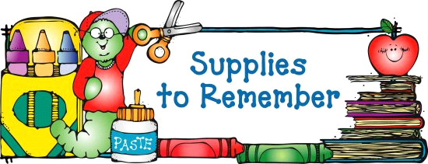

- All students must have a change of clothes to leave at school
- 2-year-old students must provide diapers and wipes, if needed
- 2 – 8 count boxes of crayons
- 1 box washable thick classic markers
- 2 bottles of regular school glue
- 1 – 4 pack of glue sticks
- 2 wood pencils
- 1 - 8 count washable watercolor paint with paint brush
- 1 pair 5″ blunt scissors
- 1 composition notebook
- Pencil pouch

Supplies needed throughout the year:
- Boys – Disinfectant wipes and/or spray
- Girls – Ziploc bags, all sizes
- Tissue Boxes

A Parent/Teacher Communication folder will be provided
by the school to each student.

Snack Rotation Schedule
The provision of daily snacks will be put on a classroom rotation with the use of a monthly snack list. You will be asked to provide the listed snack(s) for the entire class one or more times per month, based on the class size. The snack rotation list will be provided to you by your child’s teacher at Open House and every month thereafter.

