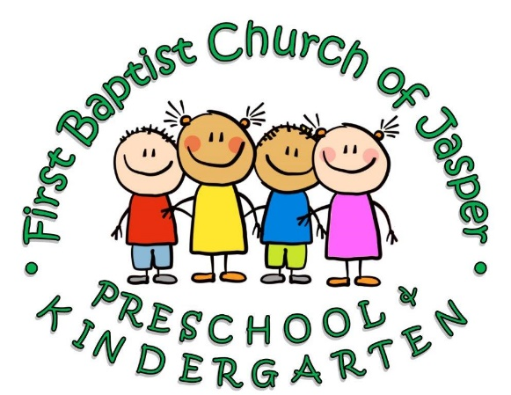
Kindergarten Information
2018-2019
Tuition Cost: $275 per month
Scholarships are available upon application.
Time: Monday- Friday 8:00 am-12:30pm
Lunch Bunch Program- 12:30pm-2:00pm
Includes a lunch period, tutoring time, and recess
- $65 per month/5 days
- $40 per month/2 days

Curriculum:
- Orton Gillingham
- iReady
- Jack and Jilly
- Sightwords.com
- Spanish Class
- Sign Language Class
- Music Class
- Your child will be prepared and ready for the next level of education after leaving FBCJ Preschool & Kindergarten. The following Georgia Standards will be met: Objectives that facilitate the development of proficiency in listening, expressing ideas, speaking and observing clearly, participating in groups, keeping healthy habits, enjoying aesthetic experiences, and living in a pluralistic society.
- The objectives of this curriculum facilitate the development of behavior based upon values of honesty and integrity, responsibility for one’s own actions, respect and concern for others, and self-acceptance and understanding.
- The Kindergarten curriculum is adequate in scope to provide for balanced experiences in the development of basic skills, recreation, health, social living, and aesthetic activities
Along with the well-balanced curriculum taught by our certified teachers, your child will also participate in daily scripture readings, bible lessons, Spanish class, sign language class, music class, computer lab, and extra library time. You will see that our schedule and atmosphere are the perfect learning environment for a well-rounded child. Our mission is to provide an excellent education integrated with biblical teachings in order to equip our students with the knowledge and beliefs that will carry them throughout their lives.

